Proposed 3DLE Firmware/App Interface Communication
ASI Audio – SDJ (ES) – January 17, 2022

dBCheck functionality is described in companion document dBCheck Functionality Programming Outline V1.docx.

Reference 3DME USB Command Structure New 20200917.docx for suggested interface codes.

These screenshots from the 3DME app are exemplary to add context to the interface needs, but will change in at least styling and appearance in the final app:

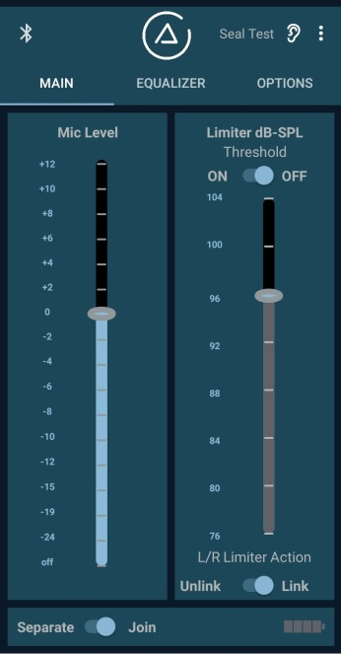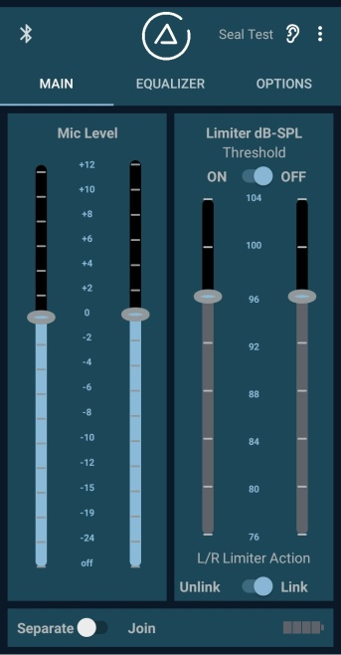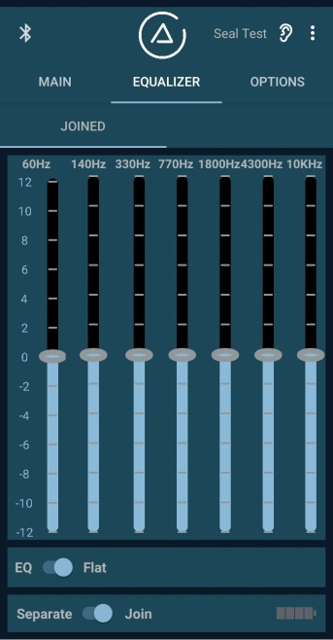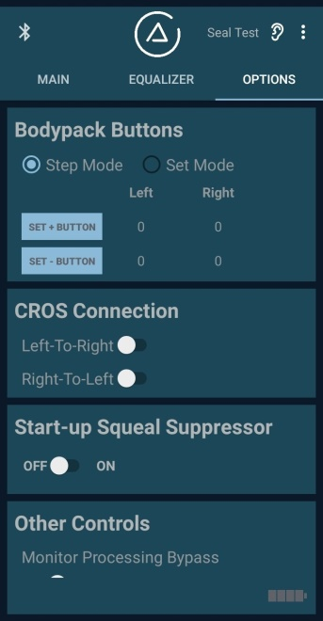

Mic Level:

Microphone (Ambience) Gain, Left and Right (calibrated as overall insertion gain)

OFF, -24, 19, -15, -12, -10, -8, -6, -4, -2, 0, +2, +4, +6, +8, +10, +12

Microphone Gain Delta, Left vs. Right
If the left and right microphone gains are set differently, this is the offset to maintain as the pushbuttons step the gain up and down. This control signal should not be necessary if the button action default is to step the left and right mic gains up and down an equal number of steps.

Button Function
This controls whether the pushbuttons are in the “Step” mode or the “Set” mode, where the buttons switch between two pre-established levels (e.g. 0 dB and -15 dB)

Up, Down button Left, Right set levels for “Set” mode button operation
As stated.

Note: The changes in Mic Level due to button presses should be reflected back immediately to the app whenever it’s connected (not just when it’s first connected or re-connected).

Note: When the app screen is switched back to “Join” from “Separate”, the Left and Right Mic gains are both set to the lower of the previous Left or Right settings, both in “Step” mode and for both settings of “Set” mode.

Note: The rough equivalent to the Monitor Input of the 3DME would here be the BT audio input. We do not provide a level control for the Monitor Input of the 3DME. As any playback app on the phone would have its level control, am I correct in assuming that our app providing level control over this input would be redundant and confusing, as would be passive earphones with their own level control? But should there be a BT audio On/Off switch, to be able to turn off any unwanted sounds emanating from a connected phone?

Limiter:

Limiter threshold, Left and Right

OFF, 104, 100, 96, 92, 88, 84, 80, 76

L/R Limiter Action Link/Unlink
As stated. (Function described elsewhere.)

Note: The Limiter ON/OFF switch acts on both Left and Right, even when thresholds are separated, as does the L/R Limiter Action Unlink/Link switch.

Note: When the app screen is switched back to “Join” from “Separate”, the Left and Right thresholds are both set to the lower of the previous Left or Right settings.

Equalizer

For each of Left, Right at 7 bands: 60, 140, 33, 770, 1800, 4300, 10k

-12, -10, -8, -6, -4, -2, 0, 2, 4, 6, 8, 10, 12

EQ/Flat
The EQ section (the DSP section in the 3DME) can be set to flat. There is an advantage to bypassing this processing in the Flat position in the 3DME (latency, dynamic range, remembering EQ settings), but if there is no advantage here, the controls can simply be set to 0 dB.

Other Functions

CROS (contralateral routing of signal)
Off, Left-To-Right, or Right-to-Left

Seal Test
On/Off

Battery Status Bars
BATT 1 & 2 & 3 & 4, BATT 1 & 2 & 3, BATT 1&2, BATT 1, SLOW BLINK BATT 1, FAST BLINK BATT 1,

Set 3DME BTLE Power (Bluetooth power in dBM)

Serial Number

Hardware Version

Firmware Version

BootLoad

Not for this product:

Quad Gain
This is for a version of the 3DME CustomTour earpiece.

Monitor Processing Bypass
This is desired for some users of the 3DME who wish to bypass the processing for the Monitor In signal. (The equivalent here would be the BT audio input.)

Not clear if needed for this product implementation:

Save default gain values

in Joining Status

Equalizer Joining Status

Limiter Joining Status

+5V Shutoff (definitely not needed)

Load all EQ at once

